  - Develop an app using Watson IoT Platform

Bluemix Lab Guide


Experience the power of IBM Bluemix
Lab 1

Activity 2: Link IoT Starter App to Watson IoT Platform
Activity 2: Link IoT Starter App to Watson IoT Platform

With Watson IoT Platform, you can manage your devices, store and access your data.
You are now going to add your smartphone as a device.
In the menu on the left side, select DEVICES:
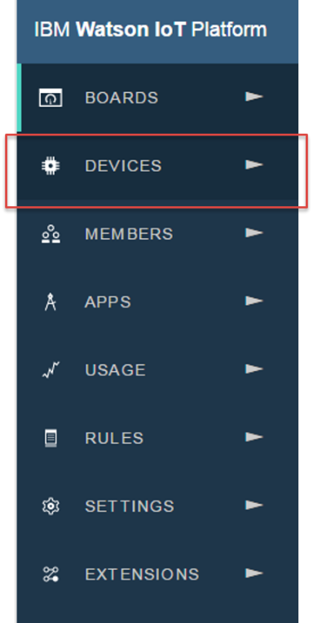
- Click on Add Device on the right:
- Click on Create device type.
- Again, click on Create device type.

- Name it “Android” if you have an Android phone or “iPhone” if you have an iPhone. You can add a description as well:
IMPORTANT NOTE: Name must be same as below (case sensitive).
- Android: for android devices
- iPhone: for iPhone
This is expected by the application as it is developed right now

- Select Next several times until the screen on step 6 below appears:

- Select the device type you just have created.

- Click Next. Give a name you want for your device (it will be your device id):

- Click Next, Next and you see the Security page below. The system will generate an authentication code if leave it blank. For ease to remember in this lab, you can enter simple token value like below. You will enter this value in IoT Starter App later.
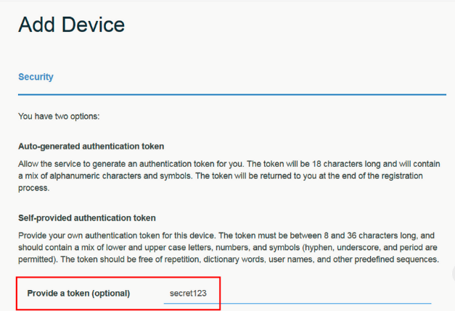

- Click Next and click on Add. Notice the following information.
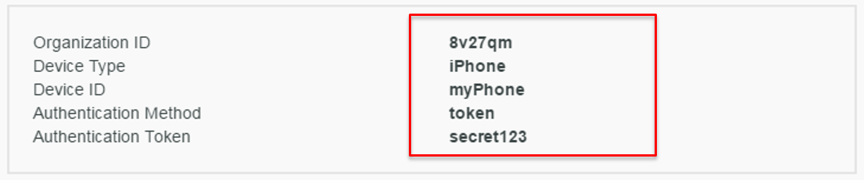
- This token is unrecoverable. Copy & paste this information in a text file and save the file. Close the device window (not the browser tab):

- Open the IoT Starter App on your smartphone and fill up your Organization ID, Device ID, Authentication Token from previous steps. (Note: iPhone and Android app has different look and feel)

- In the menu up and right, click Profiles:

Click Save setting and give a name to your profile like “myProfile”. Click “Save” and go back to the login Window. You have saved your credentials for the next time you want to connect.

- Now you can click on Activate Sensor, so your app starts to send messages to the Watson IoT platform.

- To verify message being sent from your smartphone to Watson IoT Platform, go to the Watson IoT Platform tab from your browser. Select DEVICES on the left menu and click on the device you just created.

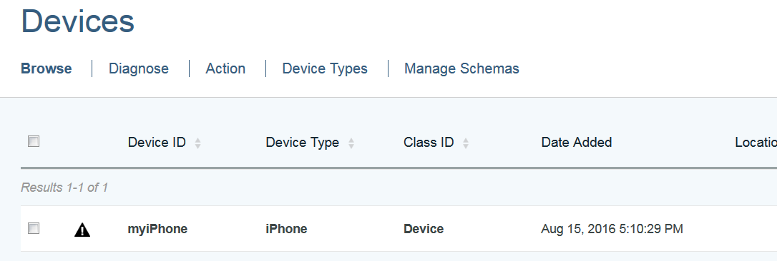

- You will see messages sent under Recent Events. The messages that are sent from your smartphone are in JSON format. You can click on the one event to see the message details which contain acceleration and position information.
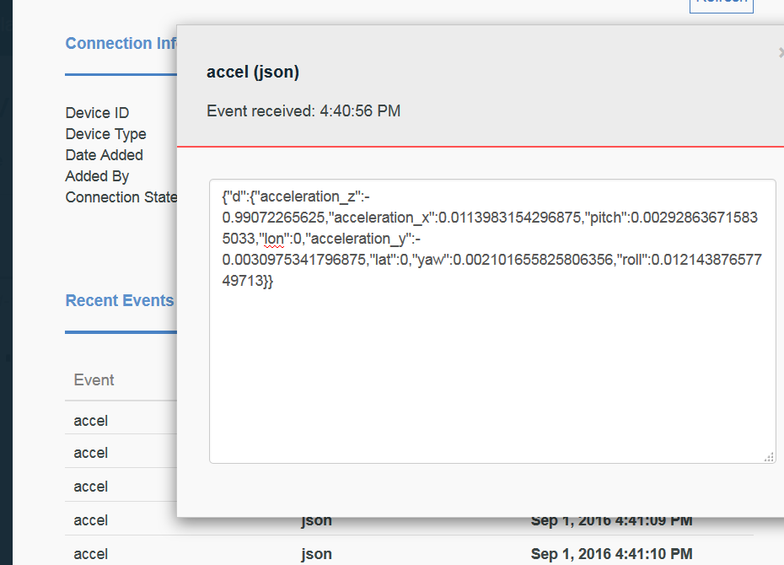

- To stop sending message from smartphone, click on Deactivate Sensor at the home page of your mobile app.

What have you completed so far?

Your smartphone is now connected to Watson IoT Platform service in Blumiex

